|  |  |  |  |  |
| --- | --- | --- | --- | --- |
|  | INTERNATIONAL TELECOMMUNICATION UNION  **TELECOMMUNICATION** **STANDARDIZATION SECTOR**  STUDY PERIOD 2022-2024 | | **Focus Group on AI Native Networks** | |
| **AINN-I-xx** | |
| **Original: English** | |
| **Question(s):** | | N/A | Virtual, TBD 2024 | |
| **INPUT DOCUMENT** | | | | |
| **Source:** | | *SRM University - Andhra Pradesh* | | |
| **Title:** | | *HeaxCore Team –* Report on ITU WTSA Hackathon 2024 *– AuRa: AuratRaksha* | | |
| **Contact:** | | Mr. Gopi Chand Janjanam | | E-mail: gopichand_janjanam@srmap.edu.in |
| **Contact:** | | Mr. Rohith Kumar Ankam | | E-mail: rohithkumar_ankam@srmap.edu.in |
| **Contact:** | | Mr. Eswar Panchakarla | | E-mail: eswar_panchakarla@srmap.edu.in |

|  |  |
| --- | --- |
| **Abstract:** | This document contains the submission of a report for *HeaxCore* Team towards ITU WTSA Hackathon 2024 for use case “AuRa: Alert, Unify, Respond, Assist towards AuratRaksha”. |

## **Use case introduction: “AuRa: Alert, Unify, Respond, Assist - AuratRaksha”**

*Ensuring Safety and Immediate Assistance for Women in Unsafe Situation or Constrained Situations*

According to the [Report](https://www.indiatoday.in/law/story/crimes-against-women-children-national-crimes-record-bureau-ncrb-data-2471938-2023-12-04), India reported a total of 58,24,946 cognizable crimes in the year 2022. Millions of women worldwide face violence, harassment, or threats in supposedly safe spaces, such as homes, offices, hospitals, public transportation, or while walking alone at night. In these situations, reaching out for help via phone calls or messages can exacerbate the danger. The fear of vengeance or escalation prevents them from seeking immediate assistance. Imagine a lady Sita, or someone close to you is in a situation where the lady is not safe. It could be at home, office, or hospital. Sita might feel it was a safe place. But unfortunately, what if she is not safe? In the privacy of her own space, someone she knows or someone she doesn't know tries to harm her?

Harmful scenarios or other dangers can persist anywhere which includes in the streets, public places, walking alone at night, traveling in train or bus, trapped in an office or home and other places having a fear and uncertainty. Sita wants to cry out for help, but the threat is too close. Reaching for her phone, making a call, or even sending a message could put her in greater danger.

*How can Sita escape from a particular harmful situation and back to a normal position? Can you help Sita?*

|  |
| --- |
| Scenario Story:  A student named Gopi from Andhra Pradesh, while he was browsing on the internet, a news report caught his eye: "India Reports 58,24,946 Cognizable Crimes". He was sad to hear that millions of women worldwide face violence, harassment, or threats in supposedly safe spaces. One line haunted him: "Many victims remain silent, fearing escalation or vengeance." Gopi thought of his close ones. Could they be next?  Gopi thinks, "What if I could create an app that lets women like Sita call for help silently?". His vision took shape: *an AI-driven safety system*, harnessing 5G/6G networks, to protect women wherever they were. With a simple, silent voice command, sita can trigger an alert. Sita’s location and live audio feed would be shared with nearest police officers, trusted volunteers and authorities. Real-time tracking and communication will ensure a swift help. Gopi's team partnered with local organizations, training volunteers to respond to alerts. They collaborated with law enforcement, streamlining the process for rapid assistance. The app launched, and the response overwhelmed Gopi. Women from across India downloaded the app, sharing stories of empowerment. Sita felt safer knowing she had a secret power in her pocket. One night, a message arrived: "Gopi, your app saved my life. I was trapped in my own home, but with the app AuRa, I whispered for help. The police arrived in minutes and I am safe. Thank you for hearing my silent cry."  Gopi’s work had made a difference. The app AuRa became a symbol of hope, a reminder that technology could be a powerful tool against violence. His story inspired others to join the fight against violence. AuRa app expanded globally, safeguarding women in every corner of the world. |

Consider the scene map below:

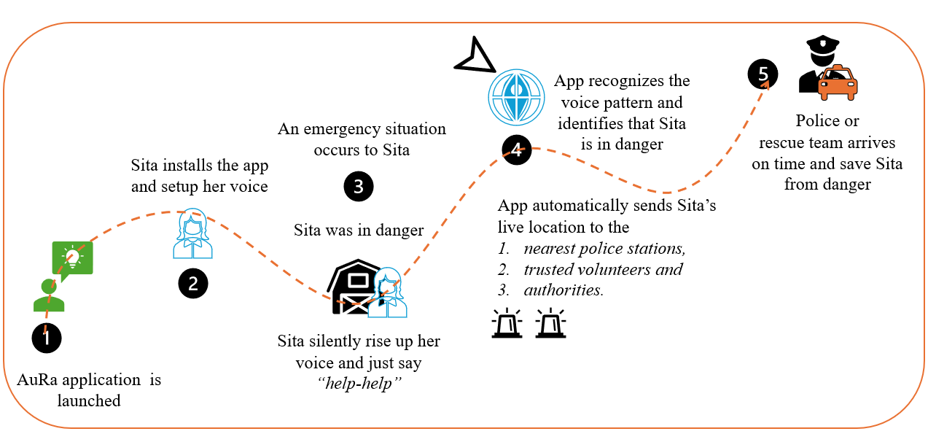

*Outline of the Use-case (Each Phase indicates the Timeline of the Scenario)*

Phase 1: “*AuRa an emergency rescue app*” is provided. Sita installs the app and sets up her voice commands successfully.

Phase 2: Later “*Sita faces an emergency situation*” and unfortunately there is no one to help her.

Phase 3: Sita “*raises her voice seeking help*”. The app which is already having Sita’s voice inputs. It automatically recognizes the voice pattern and identifies that sita is in danger. App automatically sends Sita’s live location to the nearest police stations, trusted volunteers and authorities.

Phase 4: “*Police or rescue team arrives within minutes*” identifies the situation of Sita, and immediately the police men or rescue team saves Sita from danger.

Phase 5: Sita comes out safely with the help of police officers or the rescue team, who arrives first to secure Sita from an emergency situation.

## **Use case requirements**

Requirement-1: It is critical to have Low Latency Voice, Audio, and Data Transmission.   
(The system must have 5G/6G for ultra-low latency transmission of audio and GPS data)

Requirement-2: It is critical to have a high Precision AI used to detect victims Voice and Situation. (Voice commands or emotional /harmful voices trigger the alert automatically).

Requirement-3: It is critical to have a Prioritized Resource Allocation Based on Location

Requirement-4: It is recommended to have Dynamic Resource Reallocation After Emergency Resolution. (After the emergency ends, the system should automatically reallocate network resources, Priority resources will shift back to lower-priority users)

*Our use-case has the potential to address the below United Nations Sustainable Development Goals (SDG’s)*

UN Goals

1. SDG - 3: Good Health and well being
2. SDG - 8: Decent work and economic growth
3. SDG - 9: Industry, Innovation and Infrastructure
4. SDG - 11: Sustainable cities and Communities

Justify UN Goals Selection:

* SDG-3: Our use case helps to reduce the stress and anxiety for women through enhanced safety.
* SDG-8: Our use-case focuses on social protection; women safety promotes decent work and Empowering women through safety and security boosts workforce participation.
* SDG-9: Our use-case leverages innovative technologies like OpenRAN, xApp and other AI/ML models to be considered and developing robust infrastructure for emergency responses.
* SDG-11: By using our use-case, Safe and inclusive public spaces for women will increase rapidly and lead to Community engagement and social cohesion through safety initiatives.

## **PS1: pipeline design**

* AI /ML Concept used is speech recognition, speech-text conversion, real-time data processing, anomaly detection and live racking detection.
* In Relation with ITU Y.3172 – for submission.

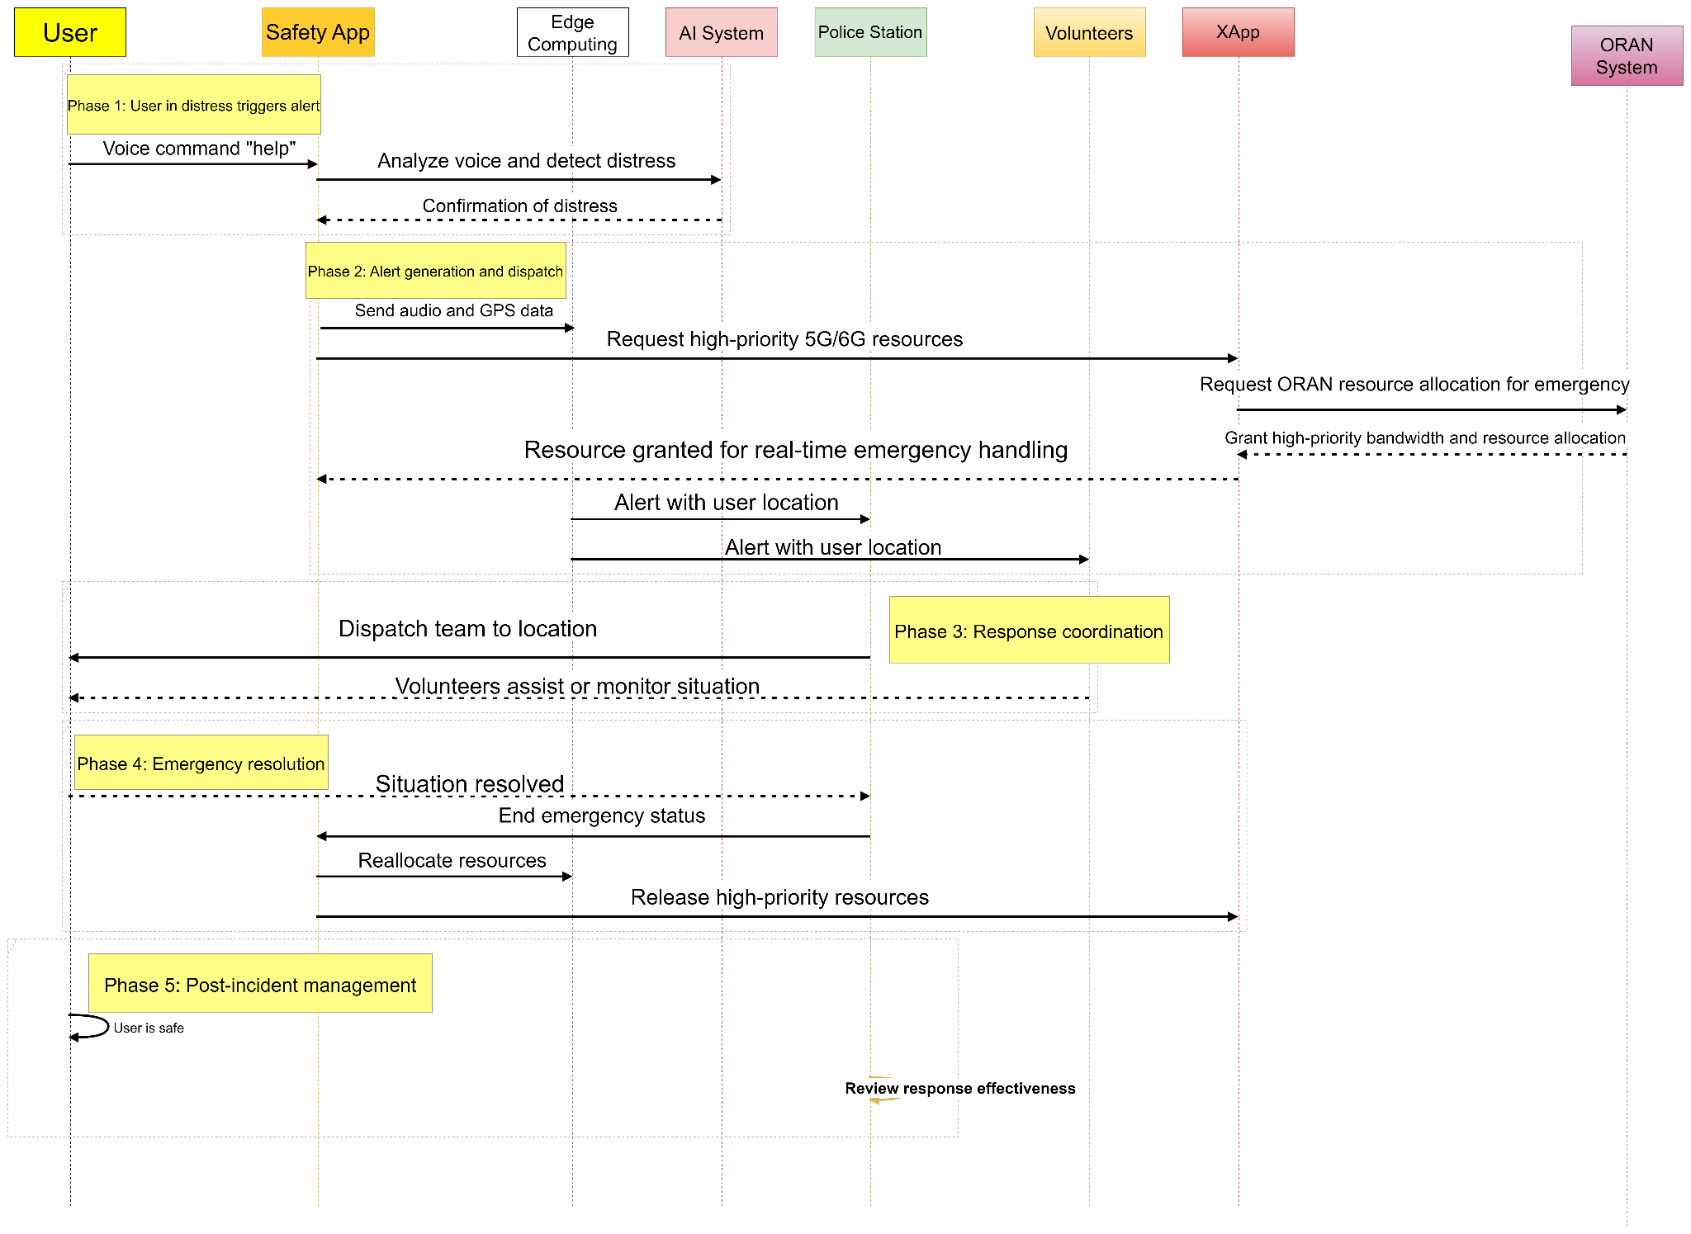

* xml link for the above sequence is here: [Aura: sequence xml file](https://viewer.diagrams.net/?tags=%7B%7D&lightbox=1&target=blank&highlight=0000ff&edit=https%3A%2F%2Fviewer.diagrams.net%2F%3Ftags%3D%257B%257D%26lightbox%3D1%26target%3Dblank%26highlight%3D0000FF%26edit%3D_blank%26layers%3D1%26nav%3D1%26title%3DPipeline%2520Design.drawio.xml%23R%253Cmxfile%253E%253Cdiagram%2520name%253D%2522Page-1%2522%2520id%253D%2522u25tTGGVU1KgiO3h-Cib%2522%253E7ZxZd6M4Fsc%252FjR9TByHWx%252Bxdc7pnMklvrzIIW6cB0SDHSX%252F6kUDCRiJeysbBnqQeCoRY%252FOenq3uvJCbwNnt7LFEx%252F4XGOJ3YVvw2gXcT27Y92%252BL%252FiZL3pgS4niyZlSSWZauCF%252FIPloWq2oLEuOpUZJSmjBTdwojmOY5YpwyVJV12qyU07d61QDNsFLxEKDVL%252FyAxmzelgWutyn%252FCZDZXdwaWPJIhVVkWVHMU0%252BVaEbyfwNuSUtZsZW%252B3OBXqKV2a8x4%252BONo%252BWIlztssJ7p833wN0My1%252FWwb%252FfWO%252F4u%252F%252F%252BuNKXuUVpQv5g3%252BrcCkfmL0rFfizF2JzkaU%252FkwSnJOd7NwUuSYYZrw%252FvUln8tCq7Wc4Jwy8FisSpSw4IL%252BPviSFeT5wD%252BH5c0uJXVM6w%252BA1WXSFNUVGRaX1vUVLiaFFW5BU%252F46rhQ5TSBRP3u23fuygsaMl4ScVKfg9RiFHFlrjimzc5Xt7H%252FN2qX%252BXfTGzv74WQ%252Fwa3B9qiCbxeO55O6drZq0r2rVbpgwu84pIRTtUHp%252FIf%252BIrjzrlWp0JJF3ls1PDv%252BJbUxHP5dkLS9JamtKxfG3zgf5bQJeGqy7YF3frmOjsKBP6c%252BG2tSLL0iCl%252Fq%252BU7r6LadticIRu2ony5aiRANZL5egPxgC1bp2yZs%252FbSK3j5huR3D5Ztg%252BUXlGAmnvm6KL6YPlemV%252Bxy5gzGkySa2uLNcYHoX3jtSOxNPdc7Du3Qs8eGOzRwFy%252BTl9zSrFgwks%252B%252BkL8A5I9krn3LGRvAjgHw9Xe%252B%252F%252FJeMZx9sXsh7OrmOohwFPWZ62ngOq51HNrD8dHuGrQ%252F0ZREwmC%252FMMQIzb%252BQvwDkoYl87OIgdvqQD%252Bwp9I7kofDIc3TMewbzv9N0kTOMy%252BqL9gugvc%252FAJ4ldG%252FhZiWLCee4ci8Oa90F9dQDDYGwtwTdawp9fMelltAFng5PT0wYw4qj3toFjOkDAHV8bCIw28J%252Fn639%252Fefxn3BgCLbnY1yFgL7Zi3N8YYteHYdzXGMLQA8GxUpVA0S8bg%252BN8cz%252B9OYRGc9jUAh5KlAkRY1TNcSw5LigHDpf3r1ybStJosG1Ie1P%252F40faH2qLekoK6wiKh7Cjd2iqHYS%252BqbYNrYHEVsNJm9Tmv40ZeuW0tjrrTMsilJJZzncjnDeWRzW3a3kgI3Esrt1rkkyRN0KyXfmt2g4mrTmGdDkgO7bXIRnCHsPhW6Gpt%252BN4QwluDnScBctgd%252FW3qjsczWZa%252FXJo1syyHwITZqgKO92gPxjMZhb4PGCGO4u%252FVd3hYDaTjhcLc%252Bj7PS5dr9yBM5TeZsLrPGB2dxZ%252Fu7qDwWzmUC4HZi1AAbbfY5ptZYU7enuDmWYzYD8Pmv2d1d%252Bu7mA0m%252BHf77QZDopolqGch93WKvKe47RYD%252BO116DLOKWM0ayTY4B3Wj5B5Q7gXZsnaHMCMgc#R%3Cmxfile%3E%3Cdiagram%20name%3D%22Page-1%22%20id%3D%22u25tTGGVU1KgiO3h-Cib%22%3E7ZxZd6M4Fsc%2FjR9TByHWx%2Bxdc7pnMklvrzIIW6cB0SDHSX%2F6kUDCRiJeysbBnqQeCoRY%2FOenq3uvJCbwNnt7LFEx%2F4XGOJ3YVvw2gXcT27Y92%2BL%2FiZL3pgS4niyZlSSWZauCF%2FIPloWq2oLEuOpUZJSmjBTdwojmOY5YpwyVJV12qyU07d61QDNsFLxEKDVL%2FyAxmzelgWutyn%2FCZDZXdwaWPJIhVVkWVHMU0%2BVaEbyfwNuSUtZsZW%2B3OBXqKV2a8x4%2BONo%2BWIlztssJ7p833wN0My1%2FWwb%2FfWO%2F4u%2F%2F%2BuNKXuUVpQv5g3%2BrcCkfmL0rFfizF2JzkaU%2FkwSnJOd7NwUuSYYZrw%2FvUln8tCq7Wc4Jwy8FisSpSw4IL%2BPviSFeT5wD%2BH5c0uJXVM6w%2BA1WXSFNUVGRaX1vUVLiaFFW5BU%2F46rhQ5TSBRP3u23fuygsaMl4ScVKfg9RiFHFlrjimzc5Xt7H%2FN2qX%2BXfTGzv74WQ%2Fwa3B9qiCbxeO55O6drZq0r2rVbpgwu84pIRTtUHp%2FIf%2BIrjzrlWp0JJF3ls1PDv%2BJbUxHP5dkLS9JamtKxfG3zgf5bQJeGqy7YF3frmOjsKBP6c%2BG2tSLL0iCl%2Fq%2BU7r6LadticIRu2ony5aiRANZL5egPxgC1bp2yZs%2FbSK3j5huR3D5Ztg%2BUXlGAmnvm6KL6YPlemV%2Bxy5gzGkySa2uLNcYHoX3jtSOxNPdc7Du3Qs8eGOzRwFy%2BTl9zSrFgwks%2B%2BkL8A5I9krn3LGRvAjgHw9Xe%2B%2F%2FJeMZx9sXsh7OrmOohwFPWZ62ngOq51HNrD8dHuGrQ%2F0ZREwmC%2FMMQIzb%2BQvwDkoYl87OIgdvqQD%2Bwp9I7kofDIc3TMewbzv9N0kTOMy%2BqL9gugvc%2FAJ4ldG%2FhZiWLCee4ci8Oa90F9dQDDYGwtwTdawp9fMelltAFng5PT0wYw4qj3toFjOkDAHV8bCIw28J%2Fn639%2Fefxn3BgCLbnY1yFgL7Zi3N8YYteHYdzXGMLQA8GxUpVA0S8bg%2BN8cz%2B9OYRGc9jUAh5KlAkRY1TNcSw5LigHDpf3r1ybStJosG1Ie1P%2F40faH2qLekoK6wiKh7Cjd2iqHYS%2BqbYNrYHEVsNJm9Tmv40ZeuW0tjrrTMsilJJZzncjnDeWRzW3a3kgI3Esrt1rkkyRN0KyXfmt2g4mrTmGdDkgO7bXIRnCHsPhW6Gpt%2BN4QwluDnScBctgd%2FW3qjsczWZa%2FXJo1syyHwITZqgKO92gPxjMZhb4PGCGO4u%2FVd3hYDaTjhcLc%2Bj7PS5dr9yBM5TeZsLrPGB2dxZ%2Fu7qDwWzmUC4HZi1AAbbfY5ptZYU7enuDmWYzYD8Pmv2d1d%2Bu7mA0m%2BHf77QZDopolqGch93WKvKe47RYD%2BO116DLOKWM0ayTY4B3Wj5B5Q7gXZsnaHMCMgci4%2F9mD%2BfxtZhQJy6f0uiv9rWreXFQywVsTOdWdFFGeJNATT2mWuZH9SST4ofu0tCsb5brd6cuSVxKnCJGXnHnMfvee31tLgV6X6tQW5Zq7dZPomCtgXvdFq5C3YeP6msPqSZErphrnkA7Wz0OTZKKy6ZT2upxwCwrM5K%2BzlH6%2Fo9A91Ui3OAbYyayZHyDcFJwZY75jJJb%2FyBu7R25dfbm1nHdbicBTgGur8ypAtEFIwHRzDvc0jwhZSZH0y2afDZ7HedD7Dwhxjs%2BcTvxNPBH8NyYFN2KpzOMWb3ifFrdEQc142FgPDXPCVruSPA0szQvuDaLaBET2hrJx6cXQSli6DysI9yE3z69sJZZUxnaYXHx%2BK0du3Njx92pZ1UJQYc%2Fe%2BC1fy7svVj7QE2DlBfZ0N%2F7AfgW9j9Y)

**Requirements for this type of application?**

* SRC of data: Voice commands
* Collector: edge server
* Models: voice pattern recognition, live tracking detection
* Policies: authentication and authorization based on recognized voice commands.
* Distributors: edge server
* Model inference Application (SINK): xApp

**Yaml code here**:

tosca_definitions_version: tosca_simple_yaml_1_3

node_types:

user_device:

derived_from: tosca.nodes.Compute

interfaces:

Standard:

inputs:

device_id:

value: { get_input: device_id }

type: string

user_id:

value: { get_input: user_id }

type: string

operations:

register: playbooks/register.yaml

unregister: playbooks/unregister.yaml

voice_recognition:

derived_from: tosca.nodes.SoftwareComponent

interfaces:

Standard:

inputs:

voice_sample:

value: { get_input: voice_sample }

type: string

operations:

recognize: playbooks/recognize.yaml

emergency_service:

derived_from: tosca.nodes.Service

interfaces:

Standard:

inputs:

location:

value: { get_input: location }

type: string

situation:

value: { get_input: situation }

type: string

operations:

alert: playbooks/alert.yaml

respond: playbooks/respond.yaml

response_team:

derived_from: tosca.nodes.Group

interfaces:

Standard:

inputs:

team_id:

value: { get_input: team_id }

type: string

operations:

dispatch: playbooks/dispatch.yaml

topology_template:

inputs:

device_id:

type: string

default: AuRa-Device-123

user_id:

type: string

default: AuRa-User-123

voice_sample:

type: string

default: AuRa-Voice-Sample

location:

type: string

default: 37.7749, -122.4194

situation:

type: string

default: Emergency

team_id:

type: string

default: AuRa-Response-Team

node_templates:

user_device1:

type: user_device

attributes:

private_address: localhost

public_address: localhost

voice_recognition1:

type: voice_recognition

requirements:

- host: user_device1

attributes:

voice_model: AuRa-Voice-Model

emergency_service1:

type: emergency_service

requirements:

- voice_recognition: voice_recognition1

attributes:

service_protocol: AuRa-Service-Protocol

response_team1:

type: response_team

requirements:

- emergency_service: emergency_service1

attributes:

team_protocol: AuRa-Team-Protocol

relationships:

- type: tosca.relationships.HostedOn

source: voice_recognition1

target: user_device1

- type: tosca.relationships_DEPENDS_ON

source: emergency_service1

target: voice_recognition1

- type: tosca.relationships_DEPENDS_ON

source: response_team1

target: emergency_service1

*Yaml code Comments:*

This TOSCA YAML code defines a service architecture for an emergency response system using TOSCA (Topology and Orchestration Specification for Cloud Applications).

* We included the features like voice recognition, user devices, response teams, emergency services, along with their relationships.
* We are assuming each relationship depends on another

1. voice_recognition1 is hosted on the user_device1
2. emergency_service1 depends on the voice_recognition1 for recognizing emergencies.
3. response_team1 depends on the emergency_service1 for dispatching help.

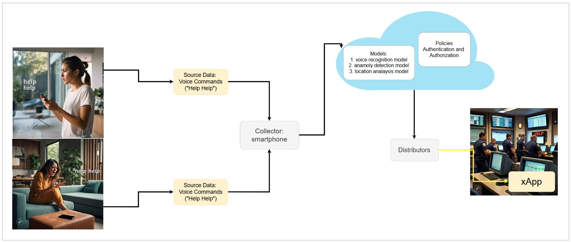

## **PS2: xApp design**

* Open RAN concept used is Priority-based QoS (Quality of Service) Optimization, AI-driven Traffic Management.
* **What is the role of xApp?**
* Real-time Event Processing: xApp processes events from various sources (e.g., voice commands, sensor data, location tracking).
* XAPP analyzes voice commands from Sita ("Help!") and triggers emergency alerts.
* **What is the role of Sandbox?**

To verify and optimize the xApp based resource allocation, operators may use AI/ML and experiment with several strategies before deploying in the field.

1. Train and fine-tune AI/ML models using simulated data and scenarios.
2. Testing and Validation purposes. Ex: Updates and Features without affecting the live system.

* (TBD)

**xApp design**:

TBD

## **Relation to Standards**

1. ITU-T Y.3173: Integrating real-time machine learning into the network for tasks like emergency detection, resource allocation, and response optimization

Example:

1. *Automation Level*: Assessing if the network can autonomously allocate resources in response to emergencies.
2. *Learning Efficiency*: How quickly your AI system learns from emergency patterns and improves its response.

TBD

## **Code submission details**

1. I created the GitHub account
2. I created the repository, made it public
3. I commit my file, added the document
4. The repository link is here: [Aura: Use-case GitHub Submission Link](https://github.com/GOPICHAND304/Use-case-from-GopiChand-for-ITU-WTSA-24-Hackathon-Submission)

## **Self-Testing results**

TBD